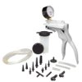
Mityvac MV8000 Automotive Test and Bleeding Kit $41.74
none

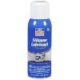
Permatex 80070 Silicone Spray Lubricant, 10.25 oz. net Aerosol Can $6.35
extra 16,90 R$

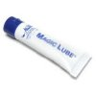
Aladdin Magic Lube 1oz Teflon Lubricant / Sealant 630 $6.99
none

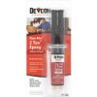
Devcon 23145 2 Ton Flow-Mix Epoxy - 14 ml Syringe $5.49
Ferramentas Gerais 7,90 R$

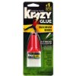
Krazy Glue KG483 Advanced Formula, .18 oz. Extra Strong, Durable, Precision Tip (EPIKG483) $4.31

extra- Super bond original 4 gramas 4,50 R$

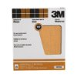
3M Pro-Pak Garnet Sanding Sheets, 150A-Grit, 9-Inch by 11-Inch $13.53

lixa para madeira 1,50 R$ ferreira costa

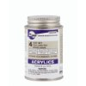
SCIGRIP 4 10308 Acrylic Solvent Cement, Water-thin, 1/4 Pint Can with Screw-on Cap, Clear $9.22
butirato, estireno, policarbonato = belmetais 250ml 16,00 R$

